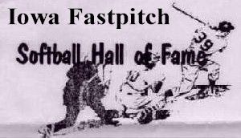
Iowa Men’s Fastpitch HOF’er
May 15, 2026
2026 Softball Reunion & Induction
Additional planning is still underway, however, the event is set for the weekend of October 24-25, 2026. Our event is only Sunday but we’re hopeful groups will plan their own overnight stays in relatively close hotels/motels so additional celebrations can occur.
Plan are for reunion and the 2026 Hall of Fame new members induction on Sunday the 25th. This will be an informal gathering for those involved in fast pitch softball and is open to all participants plus families as well as fans of the game. Be encouraged to spread the word.
2026 Softball Induction Sunday the 25th
HOF Reunion/Induction Weekend
Friday, October 25, 202 6 from 1:00pm to 7:00pm
Actual HOF Inductions Start: 3:00pm
Tara Hills Country Club
1846 70th St, Van Horne, IA 52346

2026 Special Dunk Tank Event: 2:00pm
Special thanks to dunk tank volunteers Dennis Linderbaum and Al Rausch for offering to be on the tank platform. All proceeds will support youth fast pitch softball efforts. At $1.00 for 20 balls we anticipate very active participation so we can advantage the fast pitch players of tomorrow.
Thank-you
Leroy Wegmann Tom Peterson
319-560-5254 319-230-6904
leroyweg@outlook.com Tom.Peterson@uni.edu

